5-Mar-03

Central Banks on the Move

Research note to be presented at EUSA’s 8th Biennial International Conference, March 27-29, 2003, Nashville, Tennessee, USA.

By:
Martin Marcussen, ph.d.
Associate professor
Department of Political Science
Copenhagen University
Rosenborggade 15
DK-1130 Copenhagen
Denmark
Tel: (+45) 35.32.33.96
mm@ifs.ku.dk
Central Banks on the Move

‘If the fundamental, evolutionary criterion of success is that an organization should reproduce and multiply over the world, and successfully mutate to meet the emerging challenges of time, then central banks have been conspicuously successful’ (Capie et al. 1994: 91).

A great deal has been written about the workings of central banks in the modern international financial system (see for instance Deane and Pringle, 1994; Goodhart, 1995) but we do not know much about how and under which circumstances the central bank as a public institution has spread across the globe. Classical accounts tell us that central banks appeared because states wanted to invent ways in which they could finance their war adventures (Broz, 1998). This is hardly an explanation that explains why the number of central banks has quadrupled during the last forty years. Also, we do not know much about why central bank independence has become a mantra across the world in places as different as India, Chile and Sweden. The classical explanation focuses on the role of conservative central bankers as inflation fighters (Rogoff, 1985). However, the puzzle is that central bank independence has also been introduced in countries that have not experienced hyperinflation at all (Beyeler, 2002) and that many central banks were granted more independence after inflation had been reduced rather than before (Cobham et al, 2000). The phenomenon becomes even more puzzling when it is remembered that the negative correlation between central bank independence and inflation typically breaks down (Cukierman, Webb and Neyapti, 1992; de Haan and Kooi, 2000) or simply turns into a direct positive correlation (Hillman, 1999) when the sample includes developing and transition countries.
Thus, this paper is about diffusion processes. It aspires to come to a greater understanding of how and under which circumstances practices (structures and legal standards) spread across frontiers. The paper is also about central banks. It asks which mechanisms are at stake in the diffusion of the ‘central bank’ as an organizational structure and of ‘central bank independence’ as a legal standard. In terms of conclusion the paper lists a set of plausibility probes about diffusion processes and mechanisms.

Two diffusion tracks
Diffusion studies examine how a certain kind of behavior, strategy, belief, technology, standard or structure spread from population to population (Strang and Meyer, 1993; Strang and Soul, 1998). ‘Population’ in this regard can for instance be an organization, a polity, a country or a region. A special branch of diffusion research (for an overview see Rogers, 1995) is the so-called Stanford School. The basic puzzle dealt with by this branch of diffusion scholars is why there seems to be a tendency for the social world to become increasingly isomorphic (DiMaggio and Powell, 1991; Finnemore, 1996a). Thus, in places, which in many respects are very different, one finds similar bureaucratic structures, decision-making procedures, accounting systems and constitutionally based rights and duties (McNeely, 1995; Meyer, 2000). Therefore, diffusion scholars often speak about a world society (Meyer, Boli, Thomas & Ramirez, 1997), world culture (Boli and Thomas, 2000), world polity (Boli, Loya and Loftin, 2000), world identity (Kim, 1999), world discourse (Barrett and Frank, 1999) and world authority (Boli, 1999). They typically investigate how such a world culture etc. can be defined, which actors and processes participated in the development and consolidation of this world culture and how it manifests itself in social practice.
An argument about increasing convergence on a global scale can easily be criticized on empirical as well as on theoretical grounds (Bennett, 1991; Pollitt, 2001). Therefore, it should be emphasized right from the beginning that ‘isomorphism’ as applied in this paper relates to the simple but widespread appearance of specific organizational structures and standards, and not to the way these structures and standards work in practice. Clearly, there are not two central banks that are alike and different central banks can have very different positions in their respective national polities. This fact is not disputed in this paper. Thus, defining central banking is problematic. In one sense we recognize it when we see it (Capie et al., 1994: 5). A central bank in this paper is a central bank once itself and others call it a central bank. With regard to central bank independence, a central bank is taken to be legally independent once it, through institutional reform, has achieved some degrees of autonomy from government in its pursuance of a stated objective. This is a very broad and inclusive definition of legal independence, which emphasizes that a concrete reform has taken place with a view to change the statutes of the central bank. Thus, strictly speaking, the diffusion processes that I trace and analyze in this paper can only help us understand why the concepts of a ‘central bank’ and of ‘legal independence’ have become so widely spread across the world. It can help us understand which roles these concepts play in politics and which actors and situations helped these concepts on their way.
One of the two tracks on which I focus concerns the worldwide diffusion of the ‘central bank’ as a distinct organizational structure. During the twentieth century the number of central banks rose from 19 in 1900 to reach 174 by 2000. Some parts of figure 1 almost speak for themselves. The earliest central banks (Sveriges Riksbank, 1668; The Bank of England, 1694) were created in the 17th century and for many decades, until the middle of the 18th century, the number of central banks was fairly stable. However, from the 1920s and onwards, the total number of central banks seems to grow exponentially. Today more than 90 per cent of all existing states have established central banks. In the next section, it will become clear that this curve actually hides the fact that central bank diffusion has taken place in successive waves over the years, each of which characterized by different diffusion mechanisms.

Figure 1: Sovereign States and Central Banks, 1870-2002
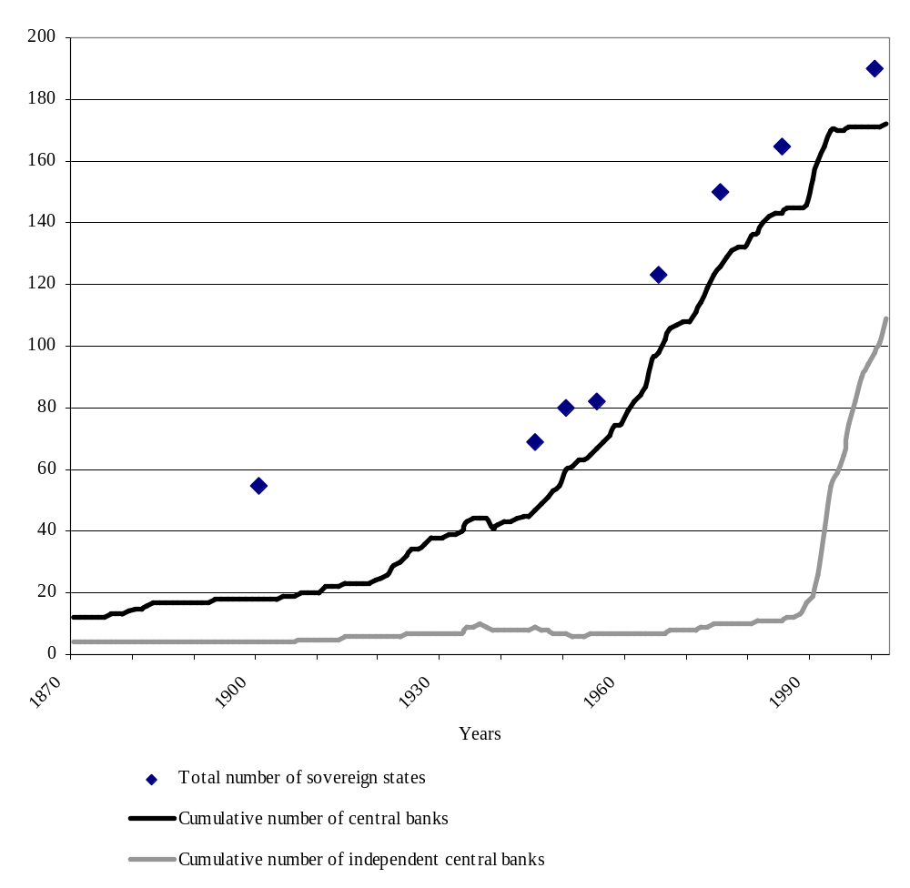
Sources: For states: Freedom House (2000), McNeely (1995: 42). For central banks: The Morgan Stanley Central Bank Directory 2003, www.centralbanknet.com. For central bank independence: Cukierman et al. (1992), Jácome H. (2001), Malizewski (2000), Maxfield (1997), McNamara (2002), www.centralbanknet.com; national central bank legislation.
Another part of figure 1 concerns the track that illustrates the diffusion of central bank independence as a legal standard. Here we see a slightly different pattern. There seems to be a radical increase in legal central bank independence during the 1990s. This movement in the 1990s is further highlighted if we look at the legally independent central banks as a proportion of the entire central bank population (figure 2). However, it is also in relation to this track that I definitely have the weakest data. A major weakness concerns the fact that the data for legal central bank independence is not based on one single definition of legal central bank independence. The data is compiled from a series of independent sources that have studied central bank constitutional reform in many different ways. However, it seems to me that the data, despite their different origins and basis, are valid because they to a large extent converge. Taken individually, the data series all show a sharp upward slope from the end of the 1980s and onwards.

Figure 2: Proportion of Central Banks With Legal Independence, 1870-2002
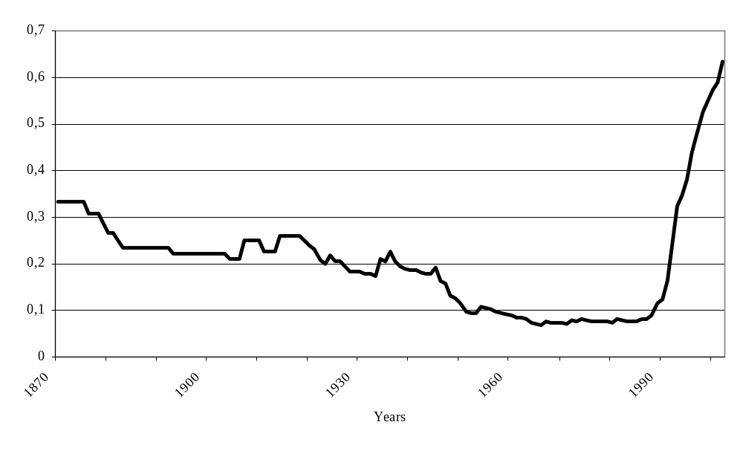
I have not gone into a discussion about when a central bank is legally independent (See Cukierman, Webb and Neyapti, 1992; Eifinger and de Haan, 1996). Rather, as mentioned, I have largely accepted the classifications and dating made by other researchers and since these data sources converge to a large degree this is sufficient for the narrow purpose of this paper. But since the paper is about diffusion processes, it might be useful to illustrate how the concept of legal independence has followed a very different diffusion track than the concept of behavioral independence (Lohmann, 1998; Maxfield, 1997). Whereas legal independence concerns the formal constitution of the central bank and its described relationship to the central government, behavioral independence concerns the question about whether a central bank in reality and in day-to-day practice has a great deal of discretion to pursue a defined objective (Blinder, 1998). Some times, as in the present period of time, legal and behavioral independence seem to coincide. However, in earlier periods of time, this was not so.
Take a look at the pendulum swings between fixed and flexible exchange rate regimes that characterize the dynamics of European monetary order throughout the last 500 years (figure 3). In the very early years, behavioral central bank independence seems to follow the monetary fashion of the day. From the beginning of the nineteenth century through to the First World War a laissez faire ideology emerged, dominated, and then faded away (Capie et al., 1994). For the central bank institutions founded in the nineteenth century and gradually emerging as central banks in the course of the century there was relative behavioral independence. The philosophy of laissez-faire dominated much of the century and under its influence the state’s role was marginal. As the century wore on, these central banks increasingly acquired the responsibility of maintaining convertibility of the currency under the gold standard. Therefore, it was natural that central banks enjoyed greater latitude at this time than in other times. Throughout the period, central banks were not, as a main rule, legally independent.
Figure 3: European Monetary Orders and Legal/Behavioral Independence
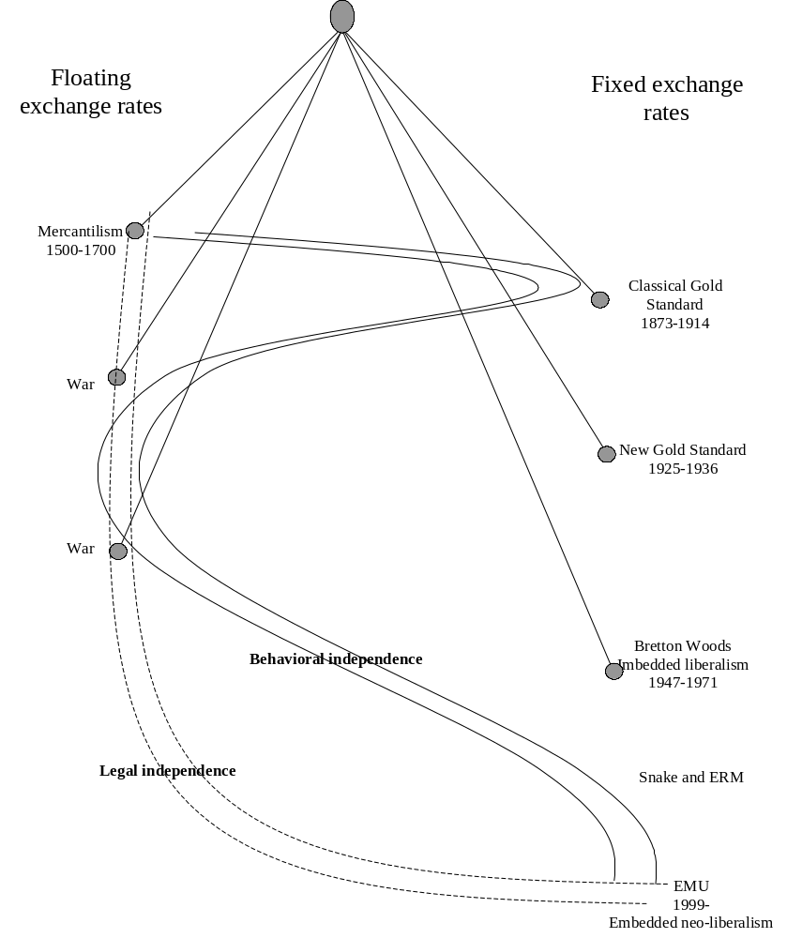
Source: Inspiration for the figure comes from Hirsch (1967: 393).
The First World War brought the period of behavioral independence to an end. In the years immediately after the war there was a well-known desire to return to behavioral independence and some movement towards that, but this was brought to an end by the first great depression and the perceived role of banking in that. The great depression of 1929-33 was regarded in many countries as a consequence of central and commercial bank failings. Behavioral reform was seen urgently required and, as one aspect of this, the state took over control of monetary politics. Behavioral independence completely lost appeal by the 1930s, and then further by the Second World War, and then more lasting by the rise of the managed economy. After the war, a series of central banks was even nationalized. These major shifts were not replicated with regard to legal independence. As in the previous period, the main rule was that central banks in term of constitutional position were legally dependent.
Only by the end of the 1980s has the trend been reversed. Now, the view developed that if central banks were less exposed to government pressure they were likely to deliver lower inflation. The desire was then for more independence (Capie et al, 1994). The era of economic management is over and we have entered a period that some have characterized as embedded neo-liberalism where not only behavioral but also legal central bank independence is high on the agenda (Rhodes and Apeldoorn, 1998).
In summary, this first section has hopefully illustrated that the central bank as an organizational structure and central bank independence as a legal standard have got diffused on a global scale. Using the diffusion studies’ terminology one can identify a certain degree of central bank isomorphism with regard to organizational structure and legal standards. The question to which I now turn concerns the explanations that can be given to explain central bank isomorphism.
Understanding diffusion processes
Functionalist explanations about why the central bank as an organizational form and independence as a legal standard have got so popular all over the world will tend to focus on the explicit demand for these structures and standards (Finnemore, 1996b). The popular version of such a demand-driven explanation will run a bit like this: ‘We have these structures and standards because they have shown to be effective in solving our immediate problems’. Thus, according to such an argument, a set of problems has been identified (lack of credibility, high inflation, malfunctioning or non-existent commercial banking etc.) and the perfect set of solutions has been chosen to solve these problems. Accordingly, if central banks and legal independence actually help states to solve their problems, then these practices will be demanded elsewhere. The success of particular triumphant central bank institutions will be evaluated and compared to the success of alternative organizational set-ups. If the central bank institution is chosen, this is because the adopters have found that central banking for them really is the optimal solution. On the other hand, if there is no relationship between the existence of central banks and their legal independence, on one hand, and solutions to the identified problems, on the other hand, then central banks, where existing, will be dissolved. Dysfunctional institutions do not have a place in such a framework.
As has been shown by other researchers, demand-driven explanations have been useful in explaining some parts of central bank diffusion. It has been argued that central banks were the only institutions that could provide governments with the credibility they needed with a view to attract money to finance major wars (Broz, 1998). It has also been argued that the creation of a central bank for some countries was the only way to create the public good of a well-functioning and stable financial system (Crockett, 1997).
However a series of researchers have suggested that there exist formal and informal alternatives to central bankers that can provide the desired public goods. Concretely, corporatism (Iversen, 1998a, 1998b; Scharpf, 1988), anti-inflation stability cultures (de Jong, 2003; Hayo, 1998) and currency boards (Dean and Pringle, 1994) are mentioned. In addition, central bankers cannot be said to be unfailing and unambiguous role models in terms of success and failures. To exemplify, in June 1994 more than 130 present and former central bank governors gathered in London at the advent of the Bank of England’s 300 years birthday. They were invited by the then Bank of England governor, Eddie George, to reflect on exactly the issue of past, present and future success and failure. To start reflections, the eminent central bank economic historian Charles Goodhart was invited to give a presentation. He concluded his presentation by arguing that the central bank as an organizational form has been successful which is evidenced in its diffusion worldwide. However, he also argued that if the criterion for success is another, i.e. that central banks worldwide had actually solved some of the problems that are around, then central banking have been, to say the least, less successful:
‘Looking at the record of domestic price stability, financial market stability, or international monetary order, the recent record is at best spotty. Despite their institutional success, central banks cannot afford to be complacent. There is much to learn, and much room for improvement’ (Capie et al., 1994: 92).
In a reaction to the presentation Fed Chairman Alan Greenspan fully agreed with that conclusion (Capie et al. 1994: 245) as did his two predecessors who questioned whether central banking really had triumphed (Volcker, 1990) and referred to ‘the anguish of central banking’ (Burns, 1979). The common view among at least American central bank governors seems to be that, on one hand, central banking and central bankers have achieved a splendid reputation worldwide but, on the other hand, there were and are a whole series of problems that have not been dealt with adequately. Just as economic theorists disagree about the relationship between legal independence and inflation, economic historians and central bank governors themselves are not looking back on a series of unambiguously successful achievements.
There seems to be a case, therefore, to supplement the classical demand-driven explanations for the diffusion of central banks with some supply-driven explanations (Finnemore, 1996b). By introducing these kinds of explanations less automatism, more social dynamics and more agency is assumed. People, organizations and states are introduced in the account as promoters of organizational forms and legal standards. Actors that play such roles have elsewhere been called norm entrepreneurs (Finnemore and Sikkink, 1998). Also, it is investigated whether states have adopted certain organizational structures and legal standards because, in world society, these structures and standards are considered as examples of modernity, progress, civilization and excellence (Meyer and Rowan, 1991; Strang and Macy, 2001). In other words, adaptive emulation of the central bank structure can take place when states without central banks desire to be considered as integral parts of world society. ‘If you want to belong to our group, and have what we have, you must be like us’! Such supply-driven accounts do not assume that the diffused structures or standards necessarily are the functionally optimal ones. Nor do they assume that dysfunctional structures and standards are automatically dismantled and left behind. Rather, we need supply-driven explanations to understand diffusion in cases where there is no obvious reason to believe that the adopted structures and standards are the only ones that can meet the challenges of the day. In short, demand-driven explanations are good at understanding the diffusion of best practice, whereas supply-driven explanations are adequate when dealing with the spread of fads and myths.
To shed light on the various diffusion mechanisms that are at stake, it is useful to look at the diffusion tracks as constituted by successive waves of organizational build-up. To exemplify the richness and variety of mechanism, we can pick out a couple of diffusion waves, without pretending that these include all existing central banks.

Figure 4: New Central Banks Per Decade
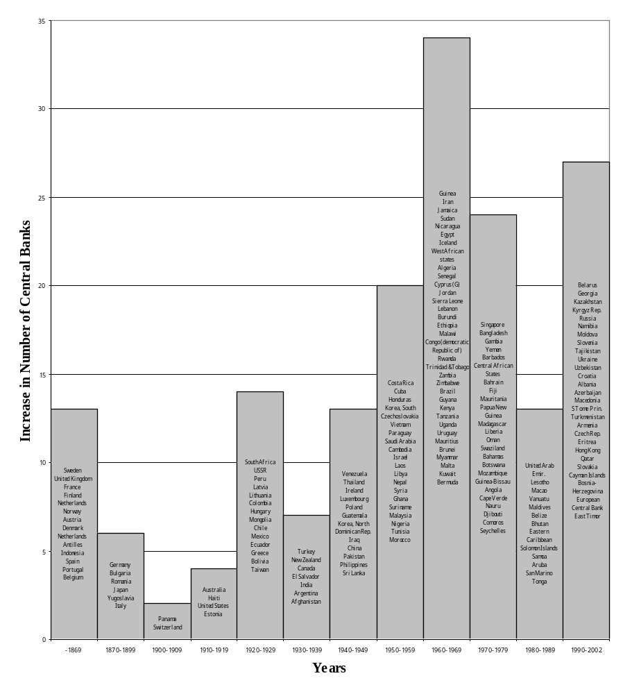

Old European Wave
Post World War I Wave
Post colonial Wave
Post Cold War Wave
The European Wave
The classical story of the origin of the earliest central banks focuses on the roles played by war and panic among commercial bankers.
The species of central banks emerged in order to raise money for governments. Thus, a central bank was, initially, seen as the government’s bank. The early central banks were nationally owned banks that undertook national obligations and in return got the right to issue bank notes. Around the time of the end of the Napoleonic wars a series of central banks were founded, for instance those of Austria-Hungary, Norway, Denmark, and the Second Bank of the United States, because the state had generated very high inflation through excessive issue of government paper currency with a view to meet its wartime expenditures (Capie et al. 1994: 4-5):
‘all ... central banks in existence before 1850 were chartered in the context of war. Some, such as the Swedish Riksbank, the Bank of England, the Bank of France, the Bank of Finland, the Bank of the Netherlands, and the Bank of Portugal, were established in the midst of war. Others, such as the first and second Banks of the United States, the Austrian National Bank, the National Bank of Norway, and the National Bank of Denmark, were set up in the immediate aftermath of war’ (Broz, 1998: 239).
By establishing a central bank these states could achieve credibility and thereby attract finances from abroad, which could be repaid over a long time horizon. One could ask why not all states that were engaged in war had established a central bank right away or, alternatively, why it took so long before Switzerland (1905), Australia (1911), United States (1913), and Canada (1935) got their central banks? Common for the early adaptors, such as Sweden (1668), Great Britain (1694), France (1800), Finland (1811), Netherlands (1814), Austria (1816), Norway (1816,) Denmark (1818), Portugal (1846), Belgium (1850), Spain (1874), and Germany (1876), is that they were all centralized or semi-centralized countries with few institutional veto-points and therefore possessed greater decision-making capacity. The latecomers, in contrary, seem to be organized according to a federal principle (Broz, 1998: 242).
Gradually, the early central banks developed to become the commercial bankers’ bank. The rationale for central banks seemed to shift around 1850, from war finance to more modern functions (Broz, 1998: 238). They started to fulfill the function as lender-of-last-resort and thus got the responsibility to avoid bank failures during financial and commercial panics. It is not the case that no other institutions could play that role. Before the period in which central bankers played the role of lender-of-last-resort, commercial bankers themselves had joined bank coalitions for that same purpose. This leads some economic historians to argue that ‘we cannot explain why governments decided to create central banks, insofar as their existence is rationalized on the grounds of lender-of-last-resort functions’ (Gorton and Huang, 2001: 36). Thus, it has been argued that the Federal Reserve (Livingston, 1986; Timberlake, 1978) and the Bank of Canada (Bordo and Redisch, 1987) were created largely for political reasons. In doing that, the well-functioning private arrangements that involved commercial banking in clearing houses were essentially nationalized.
The ‘European way’ soon started to get emulated around the world. The experience of central banks in continental Europe was leading to a consolidation of one kind of practice of how a central bank should be established and run. The Japanese, when establishing the Bank of Japan (1882) copied the Banque Nationale de Belgique as role model. When the US Congress set up the National Monetary Commission in 1908 to examine existing central bank structures, it was more enthusiastic about the German, than about the English model. Also in countries in which their banks were largely commercial and competitive, such as the Banco de España and the Sveriges Riksbank, they were now transformed into a standard central bank (Capie et al., 1994: 14). In the very early period, therefore, we see some signs of organizational diffusion. The central bank construction that existed just before World War I had become the common and standardized model for others to copy in the industrialized countries. Its very existence, its main functions and operational techniques were generally accepted and taken for granted.
The Post World War I Wave
During the Gold Standard era central bank cooperation existed in the sense that France and Great Britain supported each other’s currencies by shipping gold and silver back and forth over the channel (Capie et al. 1994: 12-13; Deane and Pringle, 1994: 54; Simmons, 1994: 21). After World War I prices were roaring in Europe and, thinking back at the glorious gold standard, everybody assumed that it could be reestablished.
Fed governor Benjamin Strong (1914-1928) has been described as a true believer in ‘internationalism’ and central bank cooperation. He was personally devoted to the Allies’ cause during World War I, he believed that Americans had a special responsibility to foster cooperation during and after the war and he engaged himself in strong Anglo-American cooperation in order to prepare for the post war international order. Indeed, ‘his internationalist activities served as a near-religious faith for him’ (Roberts, 2000: 65). At the same time he was a true believer of the Gold Standard principles of sound finances and stable prices. This was a belief he shared with British central bank governor Montagu Norman (1920-1944). As a consequence of their shared belief in stability-oriented macro-economic policy they both rejected Keynes’ views who at the time was regarded with considerable suspicion.
The two had developed close personal and professional relations already during the war and they were completely committed to reestablish central bank cooperation with a view to rebuild Europe. It has been argued that international central banking as we know it today, was largely an invention of Norman and Strong in the 1920s (Cottrell, 1995: 139). One first international meeting, at which Norman and Strong framed the agenda, was the League of Nations meeting (a so-called ‘International Financial Conference’) held in Brussels from 24th September to 8th October 1920. It attracted central bankers and their finance ministers from 39 countries (Sayers, 1976: 153-163). The European central bankers were only just getting to speaking terms with each other. However, with a remarkably broad consensus it was agreed to call for every country to have a central bank, that this central bank should be independent and that governments and central banks should return to the policy goals of the prewar era (Dean and Pringle, 1994). The secretariat of the League of Nations was asked to write up a report about the ways in which the participating countries actually responded to the recommendations. Thus, the League of Nations engaged in multilateral surveillance with a view to assure compliance with the agreed macro-economic governance principles (Pauly, 1997: 48). The conclusions of the Brussels conference were spelled out in detail at the Genoa conference (the so-called ‘International Economic Conference’), April 1922. In one out of three adopted reports, the Financial Commission of the League of Nations, primarily constituted by central bankers, it repeated the recommendations to create central banks and to restore the gold standard and its accompanying principles of independent central banking and economic conservatism. The Genoa consensus describes some embryonic ideational elements that form the basis of a nascent central bank community:
‘By the late 1920s, following conference after conference, such a consensus existed. In fact, the principles of the gold standard, fiscal conservatism, capital mobility, and non-discriminatory trade ... had become an ideology’ (Pauly, 1997: 76-77).
The League of Nations had become the meeting place for central bankers in their common strive for action against hyperinflation (Cottrell, 1995: 90). In the interwar years, the League of Nations assisted in economic restructuring in central Europe by channeling cheap loans. To these loans were attached conditions about these countries’ macro-economic governance structures, such as the existence of a central bank.
In parallel, Montagu Norman and Benjamin Strong crusaded through Central- and South America and the common wealth countries with a view to spreading the message. For his part, Norman simply refused to visit countries which had not already or were planning to establish a central bank:
‘Norman not only continued to preach the doctrine but he determined his behavior by it to an extraordinary degree. His ‘deliberate policy’, he told the Committee of Treasury, was ‘to visit only those countries having an established Central Bank’: this was given as his reason for declining an invitation to Canada. He was always glad to meet central bankers, but would refuse all contact with foreign Ministers of Finance or their officials: if some were in the same room when he met central bankers, he would confine his conversation to the latter ... this served to foster that sense of professional solidarity among central bankers on which furtherance of practical cooperation was made to depend’ (Sayers, 1976: 159-160).
Only in 1922, the year of the Genoa conference, Norman sent a letter to a dozen central banks in Central- and Eastern Europe and the British dominions with a view to set up a meeting discussing further cooperation:
‘Among the few deliberate policies consistently followed by the Bank [of England] throughout the inter-war years was it encouragement of the foundation of central banks in what may be called the Dominions ... The Bank of England – and not only its Governor - exerted itself to give the movement an impetus, to shape the new central banks in its own image’ (Sayers, 1976: 201).
Strong himself and Princeton professor Edwind Walter Kemmerer were spreading the gospel of central banking in Latin America (Capie et al. 1994: 21). Kemmerer’s career as ‘money doctor’ brought him to a long series of Central- and South American countries either representing the Fed directly or accompanied by Fed personnel. Kemmerer himself was an ardent exponent of the Gold Standard and laissez-faire, and an important element of the Kemmerer missions was to establish independent central banks that could function as lenders-of-last-resort. This directly led to the establishment of the Banco de la República de Colombia in 1923 (White, undated) and the Banco de México in 1925 (Babb, 2001) just to mention two examples. These proposed central banks were typically modeled on the Federal Reserve System.
Of today’s central banks 21 were created during the inter war years but not much came out of the plea for independent central banking (Deane and Pringle, 1994: 58; Sayers, 1976: 159). The economic catastrophe of the 1930s completely overthrew the earlier dominant ideology and a series of central banks, as mentioned above, was nationalized. However, as the 1920s closed, central bank cooperation was to be institutionalized in the Bank for International Settlements (BIS). This organization in neutral Switzerland should above all foster cooperation among central banks so in reality a central bankers club had been created (Baker, 2002; Simmons, 1993).
In summary, two types of ideational entrepreneurs helped diffuse central bank as an organizational form: the League of Nations and central bank governors. The League helped diffuse the central bank through conditional lending and through socialization in international conferences throughout the 1920s. Among the central bank governors, Benjamin Strong and associated money doctors as well as Montagu Norman stand out as internationalists with a strong belief in the gold standard and in central bank cooperation.
The Colonial Independence Wave and The Post Cold-War Wave
Since World War II, 85 former colonies have gained political independence. Most states gained independence during the 1960s (46 former colonies) and the 1970s (20). After only five years of gaining independence 54 per cent (46 states) had established a central bank. As of today, 92 per cent (78 states) of all the newly independent states have established central banks either for themselves or in monetary unions.
In the former Soviet Union and Central- and Eastern Europe, central banks, where they had existed, were abolished with the communist take over in the beginning of the century and their owners and mangers executed or driven abroad (Dean and Pringle, 1994: 291-306). With the dissolution of the Soviet Union, however, a second (post-cold war) wave of central bank diffusion materialized. Thus, between 1990 and 1992, all the newly independent states of the former Soviet Union established their own central banks.
It seems as if the diffusion pattern that we can identify from the 1960s to the present day has its own self-enforced logic. In that regard it has been argued that once international fads and norms have passed a certain threshold or tipping point the social practice – in this case the central bank as an organizational form – spreads almost by itself (Finnemore and Sikkink, 1998).
In order to be able to act in international society, to be recognized by other states, and to claim a voice in international fora any new state needs to achieve some state-like characteristics (McNeely, 1995; Meyer et al. 1997). It will adopt symbolic elements such as national hymns and national flags, it will establish rights and duties in the form of a legal system and a constitution, it will define actors and authorities such as citizens and politicians, it will adopt principled beliefs such as democracy, equality, freedom and human rights, it will construct bureaucratic systems and structures such as accounting, budgeting, ministries and central banks, and it will initiate policies within areas such as environment, education and defense. In short, any new state will do anything in its power to be like all the other states in world society as a result of which it will adopt a long series of world models that can help it to legitimate itself in the face of others (Meyer and Rowan, 1991). Since World War II, it can be argued that a tipping has been reached, i.e. that it becomes less and less a question about convincing and persuading the new states to adopt these rationalized elements of world culture and more a more a question about self-induced adaptation. Although a long series of scientific experts, private consultants, international non-governmental organizations and international economic organizations assist the new-coming states in their transformation into becoming members of world society, the states and elites therein will themselves to a large extent be major drives behind the reforms.
However, this does of course not mean that these practices, beliefs and forms function in practice! Major instances of profound decoupling between commitment and official discourse, on one hand, and actual policies, on the other, will, by necessity, take place. World models cannot simply be imported wholesale into a set of deep, often century old, pattern of myths, traditions and cultural elements. The new practices, beliefs and forms will, at best, be translated so that they resonate with existing local practices, beliefs and forms (Czarniawska and Sevón, 1996). In terms of example, the fatal economic development of former African colonies can be mentioned. Prior to political independence, these colonies typically had currency boards installed. The essential feature of a currency board is that it keeps control of the value of the local currency by rigidly fixing its value to the British pound, for example. The currency board could only issue local notes and coins in exchange for sterling at a rate fixed by legislation. Currency boards, however, were skipped as fast as the newly independent countries were freed from their colonizers - sometimes with disastrous results. Many of the newly established central banks became moneymaking instruments in the hands of dictators (Deane and Pringle, 1994: 85-96). Contrary to the system of currency boards, the newly established central banks were not constrained constitutionally to provide public goods. It was often the wildly expansionist monetary policies conducted by central bankers in these countries that led to hyperinflation in the 1970s and 1980s. For politicians and dictators in charge the abuse of central bankers was enormously profitable since the central bank has a monopoly over the supply of currency. In some countries central banks even started to collect taxes for the governments.
Thus, in order to understand the most recent diffusion processes we must supplement the mechanisms we have studied so far (wars, banking panics, ideational entrepreneurs) with the idea that sometimes states simply adopt a certain organizational structure such as a central bank because the act in itself will classify the state as being modern and developed and thereby a legitimate actor in world society. States will even skip earlier, relatively well-functioning arrangements such as currency boards with a view to introduce the world standard. Furthermore, facing economic collapse, state elites will start to rationalize the typically dysfunctional new structures.
What we have learned about diffusion processes by studying the diffusion of central banking on a world scale is two things: Firstly, the central bank institution has spread in various waves and has now become a common organizational standard for an extremely large population of sovereign states. Secondly, to explain why the central bank institution has become so successful we need to focus not only on the classical demand-driven and functionalist explanations that tend to rationalize the central bank institution as the most optimal institutional constellation. Ideational entrepreneurs, either as international economic organizations or as individual personalities, have helped the central bank fad on its way worldwide. At the same time, the spread of the central bank institution has obtained an almost self-reinforcing dynamic evidenced by the fact that a long series of state-like actors themselves are eagerly engaged in establishing central banks as a sign of statehood. These supply-driven explanations supplement rather the replace the so-called demand-driven explanations.
In the following I will take a look at the dynamics that have been decisive for the diffusion of a standard such as the legal independence of central banks.
Legal Central Bank Independence
How can we understand the very steep upward slope of the legal independence curve in figure 1? Countries in the less developed as well as in the highly developed parts of the world have undertaken profound central bank reform in the 1990s. Governments from both the right wing and the left wing have taken the initiative for such reforms. It is worth remembering that we are in fact talking about a veritable collective endeavor on a worldwide scale.
A classical demand-driven explanation will argue that states reform their central bank towards more independence because a credibility problem has arisen (Barro and Gordon, 1983; Rogoff, 1985). The nature of any government is to focus on the short time-span with a view to get reelected. By its nature the government will exploit its power over the central bank and require excessive expansionary monetary policies in order to get the economy going and growing. This will result in inflationary tendencies, which is a wrong signal to send to the financial markets. Dependent central banking thus means that foreign capital owners will not only avoid investing money in the country, they will also sell their stocks of the national currency. The case for central bank independence is closely related to the desire to reestablish the fiscal and monetary discipline that we know from the classical gold standard. An independent central bank is seen as much more credible than elected politicians, particularly if the bank is given an inflation fighting mandate.
The empirical evidence in support of the classical explanation is, as mentioned shortly in the introduction to this paper, not convincing (Hayo and Hefeker, 2002; Bowles and White, 1994). The worst argument that the classical explanation has to argue against is that ‘legal independence’ has not in a historical perspective been anywhere near actual or behavioral central bank independence (Lohmann, 1998). The extent to which legal independence sends the right and credible signals to the financial markets depends on a lot of contextual factors involving the overall administrative and political culture of the country, the general institutional configuration of the polity, bargaining patterns, actor constellations etc. (Cobham et al, 2000; Epstein, 1992; Hall and Franzese, 1998; Posen, 1993). In order to understand why countries such as Belgium, Japan and Luxembourg that were not confronted with a virulent inflation spiral undertook central bank reform anyway we will have to include other supply-driven explanations. Also, in order to understand why central bank reform took place everywhere in Europe despite the fact that low inflation had been achieved through other means prior to the reforms, we will have to look at additional explanations. Many odd questions and single cases can be mentioned that do not conform to the classical explanations for central bank reform.
Sound Policy Consensus and Ideational Entrepreneurs
What has elsewhere been referred to as ‘disciplinary neoliberalism’ (Gill, 2003), ‘market fundamentalism’ (Soros, 1998) and a ’Washington Consensus’ (Williamson, 2000) is essentially expressing the idea that sound finances, sound money and sound institutions are generally considered to be desirable objectives in themselves. Sound finances in this terminology means that public budgets ideally should be in surplus and that foreign deficits by all costs should be reduced. Sound money means low interest rates and close to stable exchange rates, and sound institutions means little state interference in the economy, privatization and independent central banking.
The International Monetary Fund and the World Bank is now described as ‘the new missionary institutions, through which these ideas were pushed on the reluctant poor countries that often needed their loans and grants’ (Stiglitz, 2002: 13). Since the days where John Maynard Keynes and others formulated the objectives of the IMF the institution has changed markedly. The IMF was ‘founded on the belief that markets often worked badly, it now champions market supremacy with ideological fervor’ (Stiglitz, 2002: 12). In a sense, the IMF lost its raison d’être with the death of the Bretton Woods fixed exchange rate system, but it soon found new roles. Indeed, the IMF does engage in large-scale institutional reform in its member countries from the Middle East, Africa, South- and Central America, Central- and Eastern Europe and in the former Soviet Union. Under the heading of ‘Technical Assistance’ IMF experts ‘contribute to the development of the productive resources of member countries by enhancing the effectiveness of economic policy and financial management’ (www.imf.org, 20 February 2003). This includes scrutiny of central banking practices and central bank legislation in the concerned countries. In the table below it is documented by the legal department of the IMF that the organization over a decade organized no less that 71 ‘technical assistance missions’ to all parts of the world with a view to reforming central bank legislation.

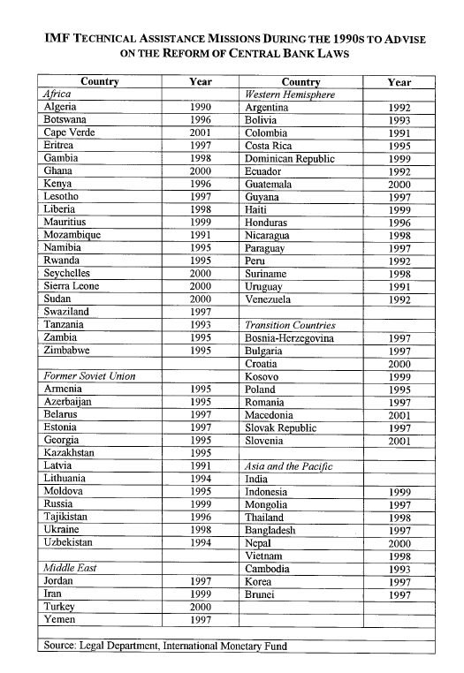
Source: Jácome H. (2001: 33)
Just to exemplify, IMF technical assistance to South Korea can be mentioned. The conditions attached to the loans granted to Korea in the midst of the 1997 ‘Korean crisis’ included a change in the statutes of the Bank of Korea to make it legally independent. Thus, the Bank of Korea was told to become more independent from commercial banking and from the Korean government as well as to focus exclusively on inflation. At the time, Korean had never had a problem with inflation, however, as a part of a standard ‘technical assistance procedure’ preceding an IMF loan the Bank of Korea was decisively told to become independent. For Korea this amounted to a huge reform which represented a revolutionary divergence from the system on which modern Korea was built (Kirk, 1999: 122). The IMF and the World Bank are not, of course, the only international economic institutions that promulgate central bank independence. The African Development Bank, The Asian Development Bank, The European Bank for Reconstruction and Development, The Bank for International Settlements, The Organization for Economic Cooperation and Development etc. are all actively talking the ‘sound policy discourse’.
In Europe, the story is different (Andrews, 2000; Cameron, 1995; Marcussen, 2000; Verdun, 1999). Central bankers were invited by the heads of state and government to formulate the basic principles for European Economic and Monetary Union. The sound money, finances and institutions doctrine was amply developed in the concluding Delors report which formed the basis for the legal and institutional set-up of the EMU and its convergence criteria.
Thus, in Europe a clear legal requirement was established that demanded profound central bank reform in a series of European Union member states. By the end of the 1980s such reforms towards increased legal independence for the national central banks were, by national parliamentarians, considered to be completely ‘un-British’, ‘un-French’ and ‘un-Swedish’ (Marcussen, 1999). However, already early in the 1990s, four years before it was actually required, the Banque de France was reformed in preparation for full participation of the third and final stage of EMU. Now central bank reform was depicted in the Assemblée Nationale as being a way for France to play a proactive role in the EU and ESCB. Great Britain had obtained a formal opt out from the third stage of EMU. However, despite the fact that no legal pressures were forcing British politicians to initiate central bank reform, the Bank of England was reformed on the first week after the Labour government had come to power in 1997. Labour politicians now defended the reform by referring to earlier periods of greatness where the independent Bank of England stood as the guarantee for British world hegemony. Sweden had not obtained an opt out from EMU since the country was a newcomer to the EU. However, when joining the EU in 1995 the Swedish politicians publicly said and wrote that they did not feel obliged to fulfill the EMU’s convergence criteria. They underlined that only a public referendum in favor of EMU could force Swedish politicians to adapt to the EMU sound policy standard. Yet, in 1997-1998 the Swedish Riksbank was fundamentally reformed. This was now considered to be in full convergence with the Swedish administrative and political culture and tradition. To explain these sudden shifts in behavior, we will need to understand that political authorities, although not necessarily under economic and legal pressure, were exposed to an ideational pressure in the European Union and from their own central bank governors. Thus, by the end of the 1980s and beginning of the 1990s the central bank stability dogma had become so widely accepted and internalized among European macro-economic elites that it came to characterize the ideational foundation of the European macro-economic institutional field (Dyson et al, 1995). This spilled over into the national political debates and caused institutional reforms. Central bank researchers have gone so far as to suggest that the power of ideas can actually best explain the ups and downs of independent central banking:
‘The switch to Keynesian principles of ‘managed money’ after World War II, the adoption of floating exchange rates and then monetary targets in the 1970s, and now the enthusiasm for central bank independence, all have owed much of their force to academic ideas whose time had arrived’ (Capie et al. 1994: 80).
What we have learned in this section strengthens the lessons drawn from studying the diffusion of central banking: there is a case for supplementing demand-driven explanations with supply-driven explanations. With regard to the diffusion of the legal independence standard in the 1990s it becomes important to systematically studying the role of ideational entrepreneurs in the form of international organizations (IMF and others) and individual central bankers (in the Delors committee and elsewhere). These entrepreneurs have actively helped the independence standard on its way in its world wide journey.
Conclusions
In this research note no systematic testing has been undertaken. The purpose has simply been to investigate whether there is a case for going any further in empirical research and theoretical development. Harry Eckstein presents a concept that describes just such an exercise: the plausibility probe:
‘[Empirical and theoretical] plausibility probes involve attempts to determine whether potential validity may reasonably be considered great enough to warrant the pains and costs of testing’ (Eckstein, 1975: 108).
On the basis of the discussion in this paper, three plausibility probes can be established:
(1) World wide isomorphism describes the result of two diffusion tracks: of the central bank as an organizational form and of independence as a legal standard.
The large majority of the existing states has already installed a central bank, and the major part of these central banks has recently been reformed with a view to obtain greater independence. Of course, nothing is said here about the ways in which these central banks function in practice. Although the Bank of England, Sveriges Riksbank and Banque de France, just to take three examples, have all been reformed recently they are different institutions in practice. They have different practices with regard to transparency and communication, they work with different objectives, their territorial organization is different and their relationships to external actors also differ. The fact that it is possible to speak about isomorphism does not, therefore, imply unequivocal and total convergence.
(2) It does not seem to be sufficient to rely on classical demand-driven explanations when studying these diffusion tracks. A case has been made in support of supply-driven explanations.
The diffusion of the central bank institution has taken place over various decades and in many waves. Each of these waves has their own logic and dynamic. The earliest waves were driven forward by wars and panic among commercial bankers. Later waves included a large amount of political entrepreneurship either in the context of international organizations such as the League of Nations or by individual central bankers and so-called money doctors. The last waves seem to have a logic of their own because central banking, since World War II, have become an integral element of statehood in world society. Any new state that wish to act as and to be considered as a sovereign actor in world society need to acquire some basic features – among these a classical central bank institution.
The diffusion of legal independence has been much faster. Although behavioral independence has gone up and down for the last four to five hundred years, wide spread legal independence is actually a quite new phenomenon. Again, we need to include supply-driven explanations and, consequently, integrate the active political strategies of international organizations and individual central bankers. Among the first, the roles of particularly the Washington based organizations have been mentioned but many others of the kind have prompted central bank reform. Among the latter, I have mentioned the group of central bankers in the Delors committee that formulated the basic principles of European Economic and Monetary Union but individual central bankers have played a role as well. The point is that the creation and functioning of monetary institutions is a highly politicized endeavor and should be studied as such.
(3) Central bankers seem to play various roles in the diffusion tracks that I have discussed.
A common myth about central bankers is that they are the masters now and that they have gained an operational as well as an ideological monopoly in macro-economic policy-making. True, Central banking has undergone a three-dimensional movement upwards, inwards and forwards. The locus for central banking has been lifted upwards from the national level to the transnational level. From being primarily focused on national policy issues, central bankers are now extremely active in dense policy networks that go beyond traditional country-specific borders and their interests are revolving around political phenomena that are global in scope. Furthermore, the forum for central banking has moved inwards. From being an integral part of national monetary policy-making, central bankers have moved their activities to more closed and exclusive fora for deliberation that do not allow for public and parliamentary scrutiny, that to a considerable degree has reduced the number of veto points, and that has depoliticized the monetary decision-making process. The independent central bankers have created their own political fields with their separate agendas and democratically decoupled procedures. Finally, the subject for central banking has moved forwards. From being background agents and servants, central bankers have now moved forward in the political process of producing ideals and meaning. Central bank ideas have been diffused worldwide and politicians on both sides of the political spectrum have accepted these. Therefore, central bankers have gained the status of principals that possess their own political legitimacy and authority. The traditional occupation of providing technically skilled and informed macro-economic management, public services and collective goods, has been supplemented by the production and diffusion of norms and consensual knowledge.
However, central banking cannot only be described in terms of a transnational, exclusive, and norm-producing central bank community. The diffusion tracks studied in this paper show that in periods of crisis central bankers have traditionally been delegated to the backside of the political process. To get the full picture of the role of central bankers in global diffusion processes the question should be asked what it takes to challenge the apparent central bank hegemony of the present day.
Literature
Andrews, David M. (2000), ‘Building Capacity: The Institutional Foundation of EMU’, Working Paper 00-2, European Union Center of California, Scripps College.
Babb, Sarah (2001), ‘The Rise of the New Money Doctors in Mexico’, paper presented at the Political Economy Research Institute, University of Massachusetts, Amherst, December 7-8.
Baker, James C. (2002), The Bank for International Settlements – Evolution and Evaluations, London: Quorum Books.
Barrett, Deborah and David John Frank (1999), ‘Population Control for National Development: From World Discourse to National Policies’, in John Boli and George M. Thomas, eds. Constructing World Culture – International Nongovernmental Organizations Since 1875, Stanford: Stanford University Press, pp. 198-221.
Barro, Robert J. and David Gordon (1983), ‘Rules, Discretion, and Reputation in a Positive Model of Monetary Policy’, Journal of Monetary Economics, 12 (July): 101-121.
Bennett, Colin J. (1991), ‘Review Article: What is Policy Convergence and What Causes It’? British Journal of Political Science, 21(2): 215-233.
Beyeler, Michelle (2002), ‘The Resiliency of Macroeconomic Policy Regimes – A Comparative Analysis of Central Bank Reform’, paper prepared for the 30th ECPR Joint Session of Workshops, Turin, 22-27 March.
Blinder, Alan S. (1998), Central Banking in Theory and Practice, Cambridge: The MIT Press.
Boli, John (1999), ‘Conclusion: World Authority Structures and Legitimations’, in John Boli and George M. Thomas, eds. Constructing World Culture – International Nongovernmental Organizations Since 1875, Stanford: Stanford University Press, pp. 267-302.
Boli, John and George M. Thomas (1999), Constructing World Culture – International Nongovernmental Organizations Since 1875, Stanford: Stanford University Press.
Bordo, Michael and Angela Redish (1987), ‘Why Did the Bank of Canada Emerge in 1935’?, Journal of Economic History, 47, 405-417.
Bowles, Paul and Gordon White (1994), ‘Central Bank Independence: A Political Economy Approach’, The Journal for Development Studies, 31(2): 235-264.
Broz, J. Lawrence (1998), ‘The Origins of Central Banking: Solutions to the Free-rider Problem’, International Organization, 52(2): 231-268.
Burns, Arthur F. (1979), ‘The Anguish of Central Banking’, The 1979 Per Jacobsson Lecture, The Per Jacobsson Foundation, Washington: International Monetary Fund.
Cameron, David R. (1995), ‘Transnational Relations and the Development of European Economic and Monetary Union’, in Thomas Risse-Kappen, ed. Bringing Transnational relations Back in – Non-State Actors, Domestic Structures and International Institutions, Cambridge. Cambridge University Press, pp. 37-78.
Capie, Forrest, Charles Goodhart, Stanley Fisher and Norbet Schnadt (1994), The Future of Central Banking – The Tercentenary Symposium of the Bank of England, Cambridge: Cambridge University Press.
Cobham, David, Stefania Cosci, Fabrizio Mattesini and Jean-Marin Serre (2000) ‘The Nature and Relevance of Central Bank Independence: An Analysis of Three European Countries’, Discussion Paper Series, no. 0017, University of St. Andrews: Department of Economics.
Crockett, Andrew (1997), ‘Why is Financial Stability a Goal of Public Policy?’, Federal Reserve Bank of Kansas City, Fourth Quarter.
Cukierman, Steven B. Webb and Bilin Neyapti (1992), ‘Measuring the Independence of Central Banks and Its Effects on Policy Outcome’, The World Bank Economic Review, 6(3): 353-398.
Czarniawska, Barbara and Guje Sevón, eds. (1996), Translating Organizational Change, New York: Walter de Gruyter.
de Haan, Jakob and Willem J. Kooi (2000), ’Does Central Bank Independence Really Matter? New Evidence for Developing Countries Using a New Indicator’, Journal of Banking and Finance, 24: 643-664.
De Jong, E. (2003), ‘Why are Price Stability and Statutory Independence of Central Banks Negatively Correlated? The Role of Culture’, European Journal of Political Economy, in press.
Dean, Marjorie and Robert Pringle (1994), The Central Banks, London: Hamish Hamilton.
DiMaggio, Paul J. and Walter W. Powell (1991), ‘The Iron Cage Revisited: Institutional Isomorphism and Collective Rationality in Organizational Fields’, in Walter W. Powell and Paul J. DiMaggio, eds. The New Institutionalism in Organizational Analysis, Chicago: The University of Chicago Press, pp. 63-82.
Dyson, Kenneth, Kevin Featherstone and George Michalopoulos (1995), ‘Strapped to the Mast: EC Central Bankers Between Global Financial Markets and Regional Integration’, Journal of European Public Policy, 2(3): 465-487.
Eckstein, Harry (1975), ‘Case Study and Theory in Political Science’, in Fred I. Greenstein and Nelson W. Polsby, eds. Strategies of Inquiry – Handbook of Political Science, volume 7, London: Addison-Wesley Publishing Company, pp. 79-137.
Eifinger, Sylvester C. W. and Jakob de Haan (1996), ‘The Political Economy of Central Bank Independence’, Special Papers in International Economics, no. 19, May, Princeton University.
Epstein, Gerald (1992), ‘Political Economy and Comparative Central Banking’, Review of Radical Political Economies, 24(1): 1-30.
Finnemore, Martha (1996a), ‘Norms, Culture, and World Politics: Insights From Sociology’s Institutionalism’, International Organization, 50(2): 325-347.
Finnemore, Martha (1996b), National Interests in International Society, Ithaca: Cornell University Press.
Finnemore, Martha and Kathryn Sikkink (1998), ‘International Norm Dynamics and Political Change’, International Organization, 52(4): 887-917.
Freedom House (2000), ‘Democracy's Century. A Survey of Global Political Change in the 20th Century’, Washington DC, Freedom House, www.freedomhouse.org/research/demcent.htm.
Gill, Stephen (2003), Power and Resistance in the New World Order, New York: Palgrave Macmillan.
Goodhart, Charles A. E. (1995), The Central Bank and the Financial System, London: MacMillan Press.
Gorton, Gary and Lixin Huang (2001), ‘Panics, Bank Coalitions, and the Origin of Central Banking’, paper presented at a conference at The Federal Reserve Bank of Cleveland’s Central Bank Institute, May 11. Forthcoming in David Altig and Bruce Smith, eds. (2003), Origin and Procedures of Central Banking, Cambridge: Cambridge University Press.
Hall, Peter A. and Robert J. Franzese Jr. (1998), ‘Mixed Signals: Central Bank Independence, Coordinated Wage Bargaining and European Monetary Union’, International Organization, 53(3): 505-535.
Hayo, Bernd (1998), ‘Inflation Culture, Central Bank Independence and Price Stability’, European Journal of Political Economy 14, 241-263.
Hayo, Bernd and Carsten Hefeker (2002), ‘Reconsidering Central Bank Independence’, European Journal of Political Economy, 18(4): 653-674.
Hillman, Arye L. (1999), ‘Political Culture and The Political Economy of Central Bank Independence’, in Mario I. Blejer and Mako Skreb, eds. Major Issues in Central Banking, Monetary Policy and Implications for Transition Economies, Amsterdam: Kluwer Academic Publishers, pp. 73-86.
Hirsch, Fred (1967), Money International, Ringwood: Penguin Books.
Iversen, Torben (1998), ‘Wage Bargaining, Central Bank Independence, and the Real Effects of Money’, International Organization, 52(3): 469-504.
Iversen, Torben (1998), ‘Wage Bargaining, Hard Money and Economic Performance: Theory and Evidence for Organized Market Economies’, British Journal of Political Science, 28(1): 31-61.
Jácome H., Luis I. (2001), ‘Legal Central Bank Independence and Inflation in Latin America During the 1990s’, IMF Working Paper, WP/01/212, Washington: IMF.
Kim, Young S. (1999), ‘Constructing a Global Identity: The Role of Esperanto’, in John Boli and George M. Thomas, eds. Constructing World Culture – International Nongovernmental Organizations Since 1875, Stanford: Stanford University Press, pp. 127-148.
Kirk, Donald (1999), Korean Crisis – Unraveling of the Miracle in the IMF Era, New York: Palgrave.
Livingston, James (1986), Origins of the Federal Reserve System: Money, Class, and Corporate Capitalism, 1890-1913, Ithaca: Cornell University Press.
Lohmann, Susanne (1998), ‘Federalism and Central Bank Independence – The Politics of German Monetary Policy’, World Politics, 50, April, 401-446.
Loya, Thomas A. and John Boli (1999), ‘Standardization in the World Polity: Technical Rationality Over Power’, in John Boli and George M. Thomas, eds. Constructing World Culture – International Nongovernmental Organizations Since 1875, Stanford: Stanford University Press, pp. 169-197.
Maliszewski, Wojciech S. (2000), ‘Central Bank Independence in Transition Economies’, Centre for Social and Economic Research (CASE), London School of Economics and Political Science, September.
Marcussen, Martin (1999), ‘The Power of EMU-Ideas: reforming Central Banks in Great Britain, France, and Sweden’, EUI Working Papers, RSC no. 99/19, Florence: European University Institute.
Marcussen, Martin (2000), Ideas and Elites: The Social Construction of Economic and Monetary Union, Aalborg: Aalborg University Press.
Maxfield, Sylvia (1997), Gatekeepers of Growth: The International Political Economy of Central Banking in Developing Countries, Princeton: Princeton University Press.
McNamara, Kathleen (2002), ‘Rational Fictions: Central Bank Independence and the Social Logic of Delegation’, West European Politics, 25(1): 47-76.
McNeely, Connie L. (1995), Constructing the Nation-State. International Organization and Prescriptive Action, London: Greenwood Press.
Meyer, John W. (2000), ‘Globalization – Sources and Effects on National States and Societies’, International Sociology, 15(2): 233-248.
Meyer, John W. and Brian Rowan (1991), ‘Institutionalized Organizations: Formal Structure as Myth and Ceremony’, in Walter W. Powell and Paul J. DiMaggio, eds. The New Institutionalism in Organizational Analysis, Chicago: The University of Chicago Press, pp. 41-62.
Meyer, John W., John Boli, George M. Thomas and Francisco O. Ramirez (1997), ‘World Society and the Nation-State’, American Journal of Sociology, 103(1): 144-181.
Pollitt, Christopher (2001), ‘Convergence: The Useful Myth’? Public Administration, 79(4): 933-947
Posen, Adam S. (1993), ‘Why Central Bank Independence Does Not Cause Low Inflation: There is No Institutional Fix for Politics’, in Robert O. Brien, ed. Finance and the International Economy,Oxford: Oxford University Press, pp. 40-65.
Rhodes, Martin and Bastiaan van Apeldoorn (1998), ‘Capital Unbound? The Transformation of European Corporate Governance’, Journal of European Public Policy, 5(3): 406-427.
Robert, Priscilla (2000), ‘Benjamin Strong, the Federal Reserve, and the Limits to Interwar American Nationalism,’ Federal Reserve Bank of Richmond Economic Quarterly, 86(2): 61-98.
Rogers, Everett M. (1995), Diffusion of Innovation, New York: Free Press.
Rogoff, Kenneth (1985), ‘The Optimal Degree of Commitment to an Intermediary Monetary Target’, The Quarterly Journal of Economics, 100(4): 1169-1189.
Sayers, R. S. (1976), The Bank of England 1891-1944, Cambridge: Cambridge University Press.
Scharpf, Fritz W. (1988)‚ ‘Inflation und Arbeitslosigkeit in Westeuropa: Eine spieltheoretische Interpretation’, Politische Vierteljahresschrift 29: 6-41.
Simmons, Beth (1993), ‘Why Innovate? Founding the Bank for International Settlements’, World Politics, 45(3): 361-405.
Soros, George (1998), The Crisis of Global Capitalism, New York: Public Affairs.
Stephens, Philip (1998), ‘The Money Masters’ Financial Times, 27 March.
Stiglitz, Joseph (2002), Globalization and Its Discontents, London: Allen Lane.
Strang, David & Sarah A. Soule (1998), ’Diffusion in Organizations and Social Movements: From Hybrid Corn to Poison Pills’, American Review of Sociology, vol. 24, 265-290.
Strang, David and John W. Meyer (1993), ‘Institutional Conditions for Diffusion’, Theory and Society, 22: 487-511.
Strang, David and Michael W. Macy (2001), ‘In Search of Excellence: Fads, Success Stories, and Adaptive Emulation’, American Journal of Sociology, 107(1): 147-182.
Timberlake, Richard (1987), The Origins of Central Banking in the United States, Cambridge: Harvard University Press.
Verdun, Amy (1999), ‘’The Role of the Delors Committee in the Creation of EMU: An Epistemic Community’? Journal of European Public Policy, 6(2): 308-328.
Volcker, Paul A. (1990), ‘The Triumph of Central Banking’? The 1990 Per Jacobsson Lecture, The Per Jacobsson Foundation, Washington: International Monetary Fund.
White, Eugene N. (undated), The Evolution of Banking Regulation in Twentieth Century Colombia, econweb-rutgers.edu/white/Publications/Bank, 24.02.2003.
Williamson, John (2000), ‘What Should the World Bank Think About the Washington Consensus’? The World Bank Research Observer, 15(2): 251-264.

For a critical examination of the vast literature on central bank independence see Hayo and Hefeker (2002).
The purpose of the paper is not to promote a set of down-to-the-detail-accurate and completely unfailing conclusions about diffusion and the role of central bankers in that regard. Not enough research has been undertaken by this author at this stage to be able to make such conclusions. The paper is the very first tentative step in an attempt to grasp the position and role of central bankers in the world polity. The paper is more a kind of background research note than it is a final product in itself. Thus, it is an attempt to kick off a three-year research project on transnational central bank communities that started on 1st January 2003. The guiding research themes in this three-year project are related to (i) the appearance, (ii) the functioning, and (iii) the effects of a transnational central bank community. Therefore, in terms of conclusion, this paper will suffice to establish a set of plausibility probes that can serve as stepping-stones for much more systematic and extensive research in the area.
The material for these figures has competently and efficiently been compiled and processed by stud.scient.pol. Hans Peter Olsen.
The distinction between ‘legal’ and ‘behavioral’ independence has also been highlighted by researchers who speak about ‘formal’ versus ‘informal’ independence (Cobham et al. 2000).
The nationalization (state ownership of 100 per cent of the share of capital of the central bank) of central banks: Danmarks Nationalbank (1936), Reserve Bank of New Zealand (1936), Bank of Canada (1938), Banque de France (1945), Bank of England (1946), Nederlandsche Bank (1948), Banque Nationale de Belgique (1948), Norges Bank (1949) and Reserve Bank of India (1949) (Capie et al. 1994: 23).
In terms of example, on the web-sites of El Banco de la República de Colombia, El Banco Central de Chile, El Banco de Reserva del Peru, Banco Central del Ecuador, El Banco Central de Bolivia etc. it is described how Kemmerer during successive visits engaged actively in the economic life of these countries.
Central Bank of West African States (8 states), Bank of Central African States (6 states) and Eastern Caribbean Central Bank (8 states).

